**MINUTES OF MEETING**

**TECHE-VERMILION FRESH WATER DISTRICT**

**August 27, 2024**

**The Board of Commissioners met on the above date at the Teche- Vermilion Fresh Water District office located at 315 South College Rd, Suite 110, Lafayette, LA 70503 at 10:00 a.m. Member’s present were: Mr. Edward Sonnier, Mr. Tommy Thibodeaux, Mr. Keith Hensgens, Mr. Donald Segura, and Mr. Samuel Grimmett. In addition, present were: Mr. Donald Sagrera, Ms. Wendy Dupuis, Mr. Larry Carmer, Dr. Whitney Broussard, Mr. Alex Lopresto, Mr. Philip Parker, Mr. Corey Hulin, Mr. William Graham, Mr.**

**Sean Reed, Mrs. Jody White, Mr. Dee Stanley, Ms. Amanada Blanchard, and Mr. Gene Sellers Jr.**

**At this time the Public meeting, the Chairman called for any public comment regarding the Agenda. There was no comment.**

**Upon motion by Mr. Hensgens and seconded by Mr. Thibodeaux, the minutes of the previous meetings of July 23, 2024 and July 30, 2024 were accepted and approved. Motion unanimously carried.**

**Larry Cramer with Sellers Associates gave an update on the Loreauville Canal Navigable Control Structure Maintenance Project and recommend Partial Payment No. 6 from Southern Constructors, LLC in the amount of**

**$153,599.52.**

**Upon motion by Mr. Segura, and seconded by Mr. Hensgens, the Board approved the recommended payment from Sellers and Associates for work performed on the Loreauville Canal Navigable Control Structure Maintenance Project. Motion unanimously carried.**

**Upon motion by Mr. Thibodeaux and seconded by Mr. Hensgens, the Board approved splitting the cost with the contractor to clear the fallen trees along the Loreauville Canal for the Loreauville Canal Navigable Control Structure Maintenance Project. Motion unanimously carried.**

**Upon motion by Mr. Thibodeaux and seconded by Mr. Hensgens, the Board approved Partial Payment No. 3 from Professional Application Services, Inc. in the amount of $21,003.65 for Masonry Restoration, waterproofing and remedial work at the Pump Station. Motion unanimously carried.**

**Upon motion by Mr. Thibodeaux and seconded by Mr. Hensgens, the Board moved to approve payment on the Masonry Restoration, waterproofing, and remedial work at the Pump Station to The Seller’s Group for reimbursable expense in the amount of $82.80 and 25% Base Fees for observation of construction phase in the amount of $673.28. Motion unanimously carried.**

**Upon motion by Mr. Thibodeaux and seconded by Mr. Hensgens, the Board approved Partial Payment No. 3 from Professional Application Services, Inc. in the amount of $30,344.40 for Cleaning and Painting of site elements at the Pump Station. Motion unanimously carried.**

**Upon motion by Mr. Thibodeaux and seconded by Mr. Hensgens, the Board moved to approve payment on the Cleaning and Painting of site elements at the Pump Station to The Seller’s Group for reimbursable expense in the amount of $82.80 and 25% Base Fees for observation of construction phase in the amount of $984.51. Motion unanimously carried.**

**Upon motion by Mr. Thibodeaux and seconded by Mr. Segura, the Board approved Proposal Request No. 2 for Cleaning and Painting of Site Elements at Pump Station. Motion unanimously carried.**

**Upon motion by Mr. Thibodeaux and seconded by Mr. Hensgens, the Board approved to move forward with the recommendations made by The Sellers Group to paint the discharge pipes. Motion unanimously carried.**

**Upon motion by Mr. Thibodeaux and seconded by Mr. Hensgens, the Board approved the Quote with Schneider Electric for $117,969.23 to complete the Electrical repairs and modernization of Pump #5. Motion unanimously carried.**

**Upon motion by Mr. Thibodeaux and seconded by Mr. Hensgens, the Board approved the Emergency call out invoice from Schneider Electric for**

**$40,415.00 for electrical repairs related to the electrical outage at the Pump Station. Motion unanimously carried.**

**Mr. Sean Reed with the Acadiana Planning Commission presented an update on the Gauge Project stating they are in the final stage of designing the gage system.**

**Mr. Donald Sagrera updated the Board on the Ruth Canal Structure stating the divers inspected the gates and found a slight leak at the bottom of the north gate and along the sides of the middle gate. The timber was solid. Sellers and Associates is moving forward with Hydraulic study and will be breaking down repairs and replacement options for the structure.**

**The Board had a Roll Call vote with 4 yeas and 0 nays for Adoption of the 2024 Approved Millage Rate of 1.42 mills.**

**Upon motion by Mr. Segura and seconded by Mr. Hensgens, the financial statements for the period ending July 31, 2024 have been approved and accepted. Motion unanimously carried.**

**Upon motion by Mr. Thibodeaux and seconded by Mr. Hensgens, the Board moved to approve payment of all bills for July 2024. Motion unanimously carried.**

**Upon motion by Mr. Thibodeaux and seconded by Mr. Segura, the Board approved Acadiana Land Services Quote of $119,000.00 to remove trees in the Ruth Canal. Motion unanimously carried.**

**Upon motion by Mr. Thibodeaux and seconded by Mr. Segura, the Board approved to formally adopt the District Storm Preparation Policy once reviewed by our legal advisor. Motion unanimously carried.**

**Upon motion by Mr. Segura and seconded by Mr. Hensgens, the Board is requesting a meeting the Clay Higgens office. Motion unanimously carried.**

**Upon motion by Mr. Thibodeaux and seconded by Mr. Segura, the Board approved the Statement that was made to the Mississippi River Commission. (see attached document) Motion unanimously carried.**

**Upon motion by Mr. Thibodeaux and seconded Mr. Hensgens, the Board approve Dr. Broussard to go forward with Water Quality Study on Bayou Amy to gather data needed to address the request for additional flow in Bayou Amy. Motion unanimously carried.**

**Upon motion by Mr. Segura and seconded by Mr. Thibodeaux, the Boad moved to approve all expenses for Commissioners and Staff to attend ALBL and MVFCA Annual meeting. Motion unanimously carried.**

**The District pumped 629,800,000 gallons for five days in July 2024. The Directors Report is attached.**

**Upon motion by Mr. Segura and seconded by Mr. Hensgens, no further business was brought forth, therefore, the meeting adjourned.**

**Edward** L. **Sonnier** Chairman Lafayette Parish

**Donald P. Segura** Vice Chairman Iberia Parish

Tommy **Thibodeaux** Secretary-Treasurer St. Martin Parish

**Keith Hensgens** Commissioner Vermilion **Parish**

**TECHE-VERMILION FRESH WATER DISTRICT**

**315 SOUTH COLLEGE ROAD· SUITE 110**

**LAFAYETTE, LOUISIANA 70503**

**PHONE: 337-233-6902 FAX: 337-233-6941** [**WATERDISTRICT@AOL.COM**](mailto:WATERDISTRICT@AOL.COM)

August22,2024

Statement to the Mississippi River Commission

**Samuel Grimmett** Teche-Vermilion Fresh Water District supplies a flow of fresh water to the Vermilion

**Advisory Commissioner**

st. Landry Parish River, Bayou Teche and the West Atchafalaya Floodway Borrow Pit Canal also called

**Donald F. Sagrera**

**Executive Director**

Bayou Amy. Our mission is accomplished by operating a series of control structures throughout the watershed which divert flows as needed to eliminate stagnation, reduce pollution, and prevent the intrusion of salt water into our waterways. When the watershed does not receive sufficient rainfall to supply adequate flow, it is supplemented by pumping water from the Atchafalaya River. The pump station is located along the Atchafalaya River about 2 miles north of Krotz Springs, La.

Congress authorized construction of the Project by the U.S. Army Corps of Engineers' New Orleans District in the Flood Control Act of 1966 as part of the Mississippi River and Tributaries Project. The cost of the project was $39.7 million. Upon its completion, the Teche-Vermilion project became the property of the people of Acadiana, who manage and operate it. It is managed and operated by a Board of Commissioners that are appointed by the parishes of the district. Each of the parishes of the district (Lafayette, Vermilion, St. Martin, and Iberia} appoint one member and St. Landry Parish appoints an advisory member. The Project is funded by a 1.5 mill property tax that was first approved by the voters of the four parishes in1970 and has been overwhelmingly approved for renewal each 1O years since. The percent favorable vote is in the upper 70% to low 80% which indicates to us that the citizens of the district appreciate the benefits that the project provides as well as the confidence in the job that the commission is doing.

The local tax income that the district receives is sufficient to operate the project during years when average rainfall occurs, and pumps are needed to supplement flow an average of 185 days per year. When more than average rainfall occurs, and less supplemental pumping is needed there is a small surplus which the charter commissioners used to create a reserve fund for major replacement and repair of features of the project that the district is required to provide. Maintaining the reserve fund is still a major priority of current commissioners. With the project having been operating 42 years the reserve fund is being used for this purpose. Because of this, the district has been able to meetits obligations and not ask for additional funding from the federal government, state government, or the taxpayers of the district.

In 2014, the district partnered with several other agencies to start a long-t_erm water quality monitoring project. That project has been successful and ongoing with no expectations of it ending. The benefits of the monitoring project to the district are that it demonstrates the importance of having a flow of fresh water through the watershed. We have also found that the water quality of the Atchafalaya River is much better than stormwater runoff from within the watershed so when pumps are running, higher quality water is flowing.

In 2023, monitoring documented that salinity levels of water in Vermilion Bay were at record high levels and saltwater intrusion occurred in lower reaches of the Vermilion River and Bayou Teche. Elevated salinity levels were also found to have entered Lake Fausse Point. The flow of fresh water that the district provided from the Krotz Springs pump station minimized saltwater intrusion and provided a source of irrigation water for many farmers in Vermilion and Iberia parishes. Without the Teche-Vermilion Project, the situation would have been disastrous.

The flow of fresh water from the Atchafalaya River through the municipalities of the district reduces fecal coliform in both Bayou Teche and the Vermilion River. Lab results for fecal coliform indicate that of the 72 samples from the Atchafalaya River at Krotz Springs over the past 6 years, 100% of the samples met the threshold for primary contact. Following rainfall runoff events in the watershed, monitoring finds that runoff reduces water quality including increased fecal coliform counts. Once the watershed is drained and fresh water pumped in, water quality improves including a reduction in fecal coliform counts.

Teche -Vermilion Fresh Water District has aggressively taken action to benefit drainage within the watershed. In addition to following those guidelines set out in our operation manual, the district has hired engineers with the University of Louisiana at Lafayette (ULL) Flood Center to conduct modeling of our flood preparation policies and asked for additional recommendations that would be beneficial. We discussed the one recommendation that was made and have incorporated it as part of our policy. In addition to the ULL studies, the district has engaged in an extensive monitoring of watershed conditions by using existing gauges and by installing more gauges and cameras. The district has also partnered with the Acadiana Planning Commission and the ULL Flood Center in a regional gauge project through which 100 additionalgauges will be installed within the watershed. This continuous monitoring of gauges helps in making decisions for operating pumps and adjusting structures to aid drainage of runoff water.

Teche-Vermilion Fresh Water District would like to include this information in the public record of this hearing and requests that you be aware of the following:

1. There is no less need for the freshwater flow in the service area than there was when the Louisiana Department of Public Works conducted the 1956 study that lead to the implementation of this project. In fact, municipal areas have grown significantly since 1956, therefore, there is a need for additional flow.
2. We have been requested, through a resolution by the St. Martin Parish Government, to provide additional flow of fresh water to Bayou Amy and the West Atchafalaya Protection Levee Borrow Pit Canal during times of low flow.
3. Coastal erosion, subsidence and sea level rise have increased the severity and frequency of saltwater intrusion in our coastal parishes. There is a need for maintaining and increasing the flow of fresh water to those areas. We have asked that this to be addressed in the Lower Mississippi River Comprehensive Study.
4. The freshwater flow that the district provides is preventing stagnation, reducing pollution, is being used for irrigation and is preventing the threat of contamination of our aquifer from being recharged with salt water.
5. White Lake is partially in Vermilion Parish and partly in Cameron Parish and Grand Lake is in Cameron Parish. Some of White Lake is in the Lower Mississippi River Comprehensive Study area. Both Lakes are in the Mermentau Basin. Both lakes provide a freshwater reservoir for those coastal parishes. It is a common occurrence for saltwater to get into these lakes during high tides and leakages. We ask that the issues that allow these lakes to be subject to saltwater intrusion and solutions to the problem be addressed in the Lower Mississippi River Comprehensive Study. This would involve expanding the study area to include the White Lake and Grand Lake area.

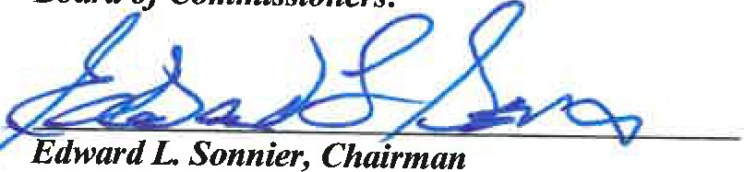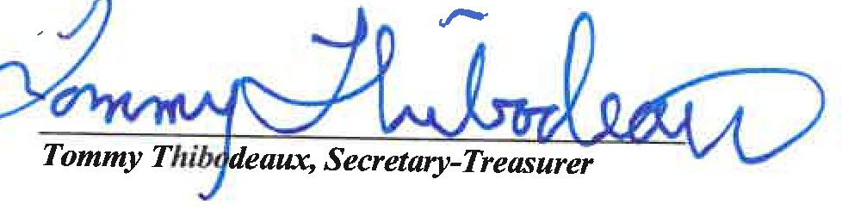

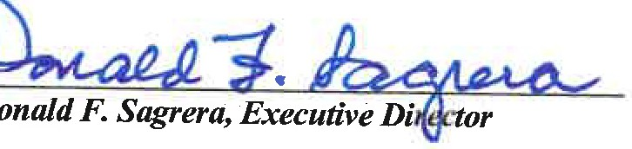

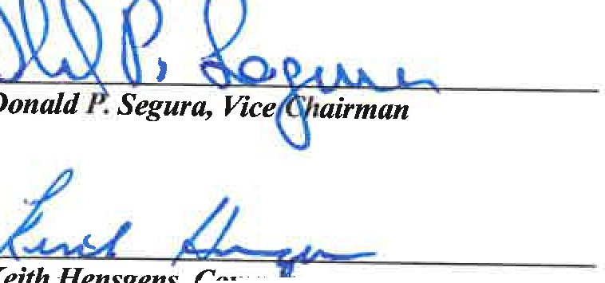

***Keith Hensgen , Com***

**Director’s Report for August 2024**

1. Acadiana Land Services has given us a proposal to remove 139 trees that have fallen or are about to fall into Ruth Canal. It will be necessary to clear the land passage to remove the trees. The quote is $119,000.00.
2. Corps visit to the pump station on August 14 - We had a group from the Corps of Engineers, La. CPRA, Wildlife and Fisheries, Congressman Higgins oﬃce, St. Martin Parish Council, Lafayette Parish Council, Acadiana Planning Commission (Acadiana Watershed District), The Nature Conservancy and the Department of Energy and Natural Resources. The purpose of the meeting was for us to provide an overview to the group on our district’s operations.

The main “take away” from the meeting from our standpoint is that we are and have been taking the same steps to prepare for storm events that we did to prepare for Hurricane Barry. Hurricane Barry preparations were cited by the Dredge the Vermilion President as being eﬀective for lowering water levels in the watershed. I spoke with the past St. Landry Parish President Bill Fontenot last week, and he told me that as he remembers the Barry event, he trusted our judgement that we would do what was the best thing and that this is what he knew we always did. In preparation for Barry, we reduced pumping, but we did not allow the elevation of Bayou Courtableau to drop below 15.63’. There has been a lot of discussion and disagreement in the past about how low it is to let Bayou Courtableau drop. It seems that there is now a consensus that the threshold is to not allow Courtableau to drop below 15.63’. Mr. John Chautin with Congressman Higgins oﬃce requested that we meet with him and explain what each of our structures does and how we prepare for hurricanes. I am asking that we pass a resolution to meet with Congressman Higgins staﬀ to explain our operations with them and plan how we can cooperate with other government agencies in hurricane preparation operations. I would also like authorization to engage the ULL Flood Center, Dr. Broussard and any other agency that would be helpful in achieving this goal. Dee Stanley and Dr. Broussard were also at the meeting and will comment.

1. Statement to Mississippi River Commission- I prepared a Statement which I asked the Mississippi River Commission to put into their record. Commissioner Dr. Robert Miller emailed me to say that it would be put into the records. I would like to read it to you and ask that each of you sign it and that we send it to all our federal and state delegations as well as our parish governing bodies.
2. On August 22, I made a presentation to the Louisiana Association of Conservation Districts Coastal Resources Committee. The meeting was held at the NRCS oﬃce

in Breaux Bridge. Jeﬀ Durand, Chairman of the St. Martin Soil and Water Conservation District made the request for me to give the presentation. Each of the

parishes of our District were in attendance. They were very interested in the beneﬁts of the ﬂow of fresh water throughout the watershed.

1. Water quality monitoring for August was conducted on August 6.

# RESULTS

Temperature (water)- Above the previous seven-year average for August by 2-3 degrees Fahrenheit. Not above the previous seven-year high.

Dissolved Oxygen- Lower than the previous seven-year average except for those samples near the Atchafalaya River water source. The Atchafalaya River sample had the highest dissolved oxygen content. The samples near the Atchafalaya River source were above the previous seven-year average which is a good thing. The lowest dissolved oxygen sites were in parts of the watershed where stormwater runoﬀ had not yet been ﬂushed. Sites on the downstream ends of both Bayou Teche and the Vermilion River showed an increase in dissolved oxygen content due to tidal exchange, wind action and boat traﬃc.

Salinity as indicated by Conductivity was lower than the previous seven-year average for all sites and was suitable for irrigation as far downstream in the Vermilion River as the GIWW site. Salinity was above the threshold for irrigation use for both the Cypremort Point and Lake Fearman sites.

# Turbidity- Water clarity was near the previous seven-year average for most sites. A notable increase in clarity was found in that part of the Vermilion River from Milton to Perry. It is believed that this is a section of water that drained from a retention area where sediments settled out of the stagnant water before it drained (possibly Cypress Island Swamp).

Fecal Coliform- All samples for both Teche and Vermilion related sites were within the secondary contact threshold. For the Teche related sites, three were above the primary contact threshold (Belle Place, New Iberia and Hwy 3195) and one site was above the primary threshold for the Vermilion related sites (Palmetto Park).

1. Meeting with Lafayette Parish Council Chairman Bryan Tabor, Dredge the Vermilion Representatives and two Commissioners of Teche-Vermilion Fresh Water District.

# Rachel Godeau with Mayor-President Boulet’s office also attended. Councilman Tabor called the meeting to address issues that Dredge the Vermilion leadership have been raising concerning Teche-Vermilion Fresh water District. The main points of discussion were preparation for storm events and the need for our reserve fund. Todd with Sellers and Associates explained the Reserve fund study and we explained our storm preparations. Dee Stanley was taking notes at the meeting and will comment.

1. Update on St. Martin request- Dr. Broussard will report
2. List of projects beginning and completion-
   1. Loreauville Canal- Ongoing-Completion will be discussed at meeting.
   2. Electrical upgrades- Ongoing-Will be discussed at meeting.
   3. Painting of pump station and site elements-Ongoing-will be discussed at meeting.
   4. Gauge Project-Ongoing-Will be discussed at meeting.
   5. Ruth Canal Project-Started-Will be discussed at the meeting.
   6. Borrow Pit Control Structure (St. Martin Parish request)-In study phase-Will discuss

at meeting.

* 1. Stabilization of the banks of the Atchafalaya River at the intersection of our inlet channel. Preliminary discussion and investigation began.
  2. Inspection and repair of the Borrow Pit Control Structure (we will need a passage for ﬂow during this operation).
  3. Inspection of the original State Canal Structure. Preliminary discussions with

engineers started.

1. December meetings in New Orleans- The Association of Levee Boards of Louisiana is December 4-5, and the Mississippi Valley Flood Control Association is December 5-7. We need a motion for commissioners and staﬀ to attend.
2. In addition to the major electrical problem at the pump station, we also had mechanical problems once we started pumping. We have been getting the mechanical problems ﬁxed thanks to our vendors who have been working after hours and on weekends to help us run enough pumps to maintain the optimum ﬂow.
3. Schedule Inspection of structures with La.CPRA-
4. Inspection Report Presentation- Is scheduled for October 18.
5. Pumping report. We pumped 5 days in July and so far, 22 days in August for a total of 56

days so far this year.